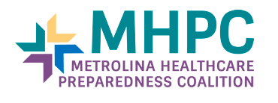

HVA TOOL PILOT

Healthcare and Public Health Sector Risk Assessment Tools Pilot
Thank you for your interest in participating in the Healthcare and Public Health Sector Risk Assessment Tools Pilot. Please go to http://www.metrolinapreparedness.org/hva-tool-pilot to complete the THAM HVA.
What we are looking for is your assistance with inputting data into the tools to make sure:
- The process makes sense
- The output data is actionable for decision-making
- Feedback on how the tools compare to what you are currently using
- Feedback on how to improve the tools

MHPC Project Timeline/Deliverables:
- Tools are available now (below) for you to access and utilize
- The MHPC would also like a copy of your results, if possible, to use in compiling a Regional HVA to test that portion of the tool.

Important Things to Know:
- Scroll down to the middle of the page in the section entitled “Program Tools” and click on Part 1 – Threat Hazard Assessment Module
- You MUST “Enable Macros” when you FIRST open the program/workbook. If you don’t, you will need to delete and re-download.
- You data will be stored on your computer, not on a state or federal server.
- The tool can be completed by a single person, or by a full planning team. If completed by a single person, the end product works well to facilitate discussion amongst your planning team to review and verify the results.

