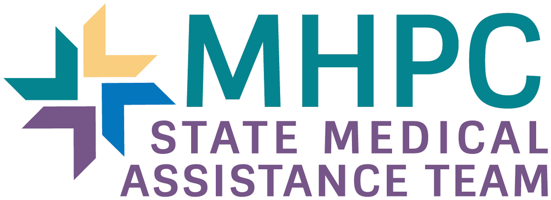

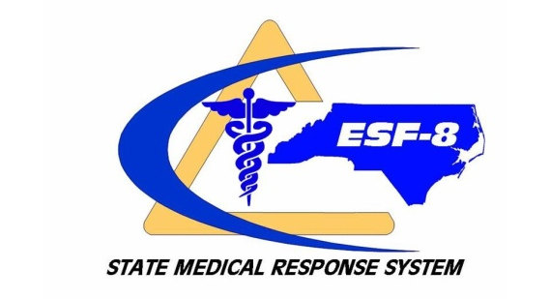

SMAT II

Information Tool

Please return to:

Scott Hess
Assistant Regional Coordinator
Metrolina Healthcare Preparedness Coalition
Email: Michael.Hess@carolinas.org
Cell: 704-221-2818

-SMRS Mission-

To ensure the delivery of healthcare services that protect the health and well-being of the residents and guests of North Carolina before, during, and after events that may overwhelm the healthcare system.

-Introduction-

The terrorist attacks of September 11, 2001 and subsequent anthrax exposures have ignited a renewed commitment in the state of North Carolina to strengthen our readiness and our capacity to respond to a terrorist attack. Numerous local, state, and regional agencies are collaborating on multiple scenarios that exist now that the threat of terrorism is real. Specifically, four agencies have recently joined efforts to consider the treatment and response phase of a terrorist event. The agencies include the North Carolina Office of Emergency Medical Services (NCOEMS); the North Carolina Division of Emergency Management (NCEM); the North Carolina Division of Public Health - Epidemiology & Communicable Disease (NCPH); and, formerly, the Special Operations Response Team (SORT). These agencies represent the management system responsible for coordinating a disaster response, ensuring that treatment and prevention strategies are implemented, as well as disease surveillance and medical preparedness. The goal of this effort is to assure our citizens that when a terrorist attack or natural disaster occurs in North Carolina they will be able to get the medical care services they need to protect their health and prevent the further spread of disease. Priorities include enhancing disease monitoring and investigation systems, improving communication capabilities among health agencies and building the medical response capacity.

The agencies have collaborated to develop a tiered State Medical Response System (SMRS) plan; within that plan are eight (8) Regional State Medical Assistance Teams Type II.

Our team is looking for qualified applicants to provide various services to support our deployment and patient care efforts. If you are interested in being part of our team please read on and more information will be provided as to the make-up and structure of our team!

-Composition and Structure-

Our team structure is currently in transition as we work to create more volunteer leadership roles. The program is lead by three grant-funded employees who oversee the SMAT, as well as the Metrolina Healthcare Preparedness Coalition (MHPC) that supports Hospitals, EMS, Public Health, and Emergency Management across a 13 county region. The program is lead by a Healthcare Preparedness Coordinator (HPC), and two Assistant HPC’s… one for Planning and Finance, and one for Operations and Logistics. SMAT members are primarily coordinated by Operations and Logistics, but receive leadership and guidance from all MHPC staff.

We are recruiting members who are willing to provide services to support our efforts. Not all members are medical professionals. We are composed of two (2) general areas:

- Medical
  - Nurses
  - Paramedics & EMTs
  - Physicians
  - Respiratory Therapists
  - Pharmacist
  - Mental Health Professionals
  - Social Workers
  - Advanced Level Practitioners
  - Allied Health Professionals

- Non-medical Support
  - Fire Fighters
  - Hazmat Technicians
  - Law Enforcement/Security professionals
  - Support Staff
  - Amateur Radio Operators
  - Translators/ Interpreters (any languages, incl. ASL)
  - CDL Drivers
  - Specialists in HVAC, Plumbing, Electrical work, etc
  - Information Technology

SMAT members will be required to complete the SMAT Initial Training Program and meet their team specific training or participation requirements.

If you haven’t done so already, each SMAT member must establish and maintain an account and be registered thru ServNC – the on-line state disaster volunteer registry at www.servnc.org. Choose Metrolina SMAT II as team affiliation.

SMAT operations are a great way to give back to the community in which you live and work, while helping others in their immediate time of need.

The Metrolina SMAT is divided into 3 groups:
- Active Responders
  - Completed all required training
  - Able to deploy outside of the local area for 1-14 days
  - Provide 20 hours of participation a year
- Reserve Responder
  - Unable to deploy outside of the local area, but whiling to assist at “home”
  - Provide 12 hours of participation a year
- Providers (Physicians, Physician Assistants, Nurse Practitioners, Pharmacists)
  - Competed focused training
  - Whiling to deploy on a case-by-case basis
Please see the attached membership Requirements for additional information.

SMAT II Member Personnel Data Form
(Confidential information, not for distribution)

***YOU CAN SKIP THIS SECTION IF YOU HAVE ALREADY COMPLETED YOUR SERVNC PROFILE***

Last Name: _____________________________________________________________

First Name: ______________________ Middle Initial: ______ Suffix (Jr, II, etc)_____

Address: _______________________________________________________________

City: _____________________ State: _________ Zip Code: ________

Home Phone ________________________________

Work Phone ________________________________

Cell phone ____________________________ Pager _____________________________

E-Mail: _____________________________________

Fax: _________________________________________

Gender: Male _________ Female _________

Driver’s License State & #: ____ _____________ Class: ____ Expiration Date: _________

Please indicate area of specialty:
- Physician
- Nurse Practitioner/Physician Assistant
- RN
- Paramedic
- Respiratory Therapist
- Pharmacist
- Mental Health Professional
- Clerical
- Support
- Other ______________________________________________________

Current Employer: ______________________________________________________

Current Department: _____________________________________________________

Name of Supervisor/Manager and contact number: ___________________________

- Emergency Contact(s) ____________________ Relationship ______________

Emergency Contact Numbers: ____________________________________________

2) Emergency Contact(s) ____________________ Relationship ______________

Emergency Contact Numbers: ____________________________________________

3) Emergency Contact(s) ____________________ Relationship ______________

Emergency Contact Numbers: ____________________________________________

***RESUME COMPLETLING THE APPLICATION HERE IF YOU SKIPPED THE SECTION ABOVE***

If the answer to any of the following questions is “Yes” please provide a brief explanation.

- Have you ever been subject to an inquiry or investigation by any licensing board or certifying agency?
YES______ NO______
If so, please explain______________________________________________________ _______________________________________________________________________

- Have you ever been discharged or asked to resign from a previous employer?
YES______ NO______
If so, please explain______________________________________________________
_______________________________________________________________________

- Have you ever plead guilty to or been convicted of a crime (felony or misdemeanor?
YES______ NO______
If so, please explain______________________________________________________
_______________________________________________________________________

- Do you have any current restrictions on your driver’s license?
YES______ NO______
If so, please explain______________________________________________________
_______________________________________________________________________

Team Member Eligibility Requirements

Indicate if you are willing and /or able to meet the following criteria:

Yes____ No____ Complete initial training (minimum of 36 hours) and continuing education requirements

Yes____ No____ Ability to deploy with team when activated within 24-48 hour notice

Yes____ No____ Willing to be deployed for up to 14 days

Yes____ No____ Maintain a 7 day personal pack

Yes____ No____ Submit a record of Tetanus Toxoid vaccination within last 10 years

Yes____ No____ Submit a record of Hepatitis B vaccinations (series of 3 vaccines) within last 10 years with a positive titer

Yes____ No____ Submit a record of TB Skin Test and if positive, a chest x-ray report

If you answered “No” to any of the above, please provide a brief explanation.
____________________________________________________________________________________________________________________________________________________________

I, __________________________________________ acknowledge the information contained within this SMAT II application is accurate.

___________________________________ ___________________________
Signature Date

* Please provide a resume or complete the Member Qualification and Position Assignment Tool. We would like to know, for example, if you are a Registered Nurse, are you a hospice nurse, ER nurse, Pediatric nurse? This will help us to identify how best to utilize your skills and talents.

