EMPLOYEE MONITORING TOOL (COVID-19)
Associate Name: ________________________ Dept: _________Date: ________ Time: ______ Pre-Checker Name: ________________________
1. Select place close to entrance for screening. Ideally a separate employee entrance with limited traffic.
2. Ask person to knock on door and screen for symptoms of respiratory illness.
Do you have a: | Yes | No | Comments
Fever
New or worsening cough
Shortness of breath
Sore throat
Chills
Muscle Pain
New loss of taste or smell

If employee answers NO to ALL screening questions, the screener should complete a screening ticket for employee to give to shift supervisor. Employee may begin work shift.
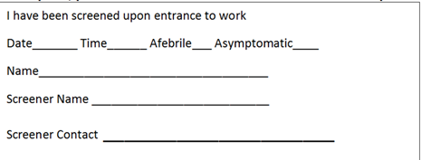

If employee answers YES to any of the screening questions the employee should not work. The employee should self-isolate at home. Contact the supervisor and infection prevention. Infection Prevention should notify the local health department.
If the employee does NOT have a fever, new or worsening cough, shortness of breath, or a sore throat, but, is experiencing mild respiratory illness the employee may work if they have been fever-free for 72 hours and their symptoms are improving. While at work, the employee must don a facemask. The facemask must be worn at all times except when the employee is at the nurses’ station.
READ BELOW to EMPLOYEE:
IF developing ANY NEW symptoms (cough, shortness of breath, fever) please do the following:
- IF at Work: Immediately STOP direct patient care, perform hand hygiene, put on a surgical mask, notify your supervisor or house Supervisor, and wait for instructions.
- IF at HOME: STAY HOME, self-isolate and follow the Health Department instructions, and let your manager know you are not coming to work.

